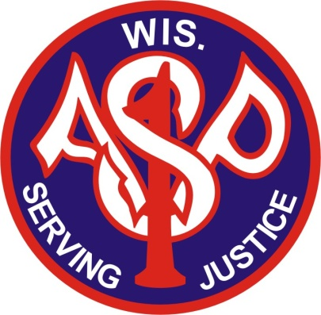
Association of
SWAT Personnel – Wisconsin Ltd.
Est. 1982
SPONSORSHIP LEVELS

Platinum Level $5000.00 Value

Conference recognition
Company Logo as part of the main page of ASP Website
Company Logo on all Constant Contact emails
Company Logo on all Social Media postings.
Company Logo on all Banners and Backdrops for the years Conference.
Company Booth Space for annual conference.

Gold Level $3000.00 Value

Company Logo as part of the Sponsor Page of ASP Website
Company logo on social media postings specific to the company’s products
½ price booth space.

Silver Level $1000.00 Value

Company Logo on sponsor page as part of a paid booth space at the annual conference.

